Name:
Course/section:
Date
HW #
Chapter:

Instructions: Show all steps in your work to get full credit

- Find the resultant force for the forces shown by (a) using the parallelogram law and (b) by resolving the forces into their x and y components.
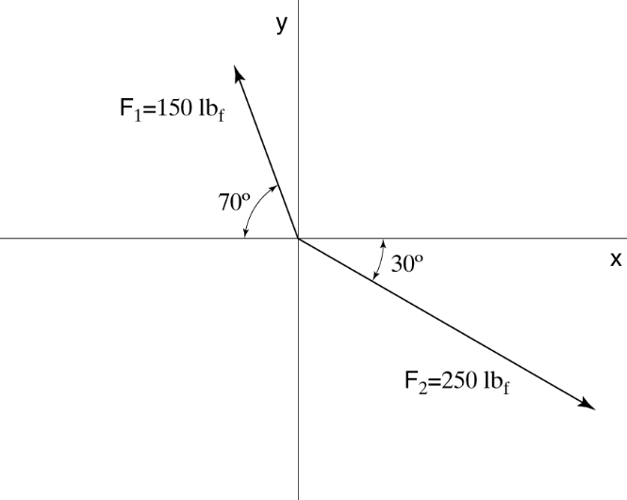

- Consider the three forces, F₁ = 5 i + 2 j kN, F₂ = −3 i − 8 j kN and F₃ = −4 i + 7 j kN. Find the resultant force, its magnitude, and direction with respect to the positive x-axis.

- A crate hangs by a rope as shown. Construct a free-body diagram of the crate.

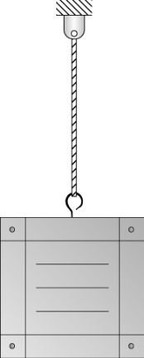

- A 15-kg flowerpot hangs from wires as shown. Find the tension in wires AB and AC. Use the general analysis procedure to present your solution.

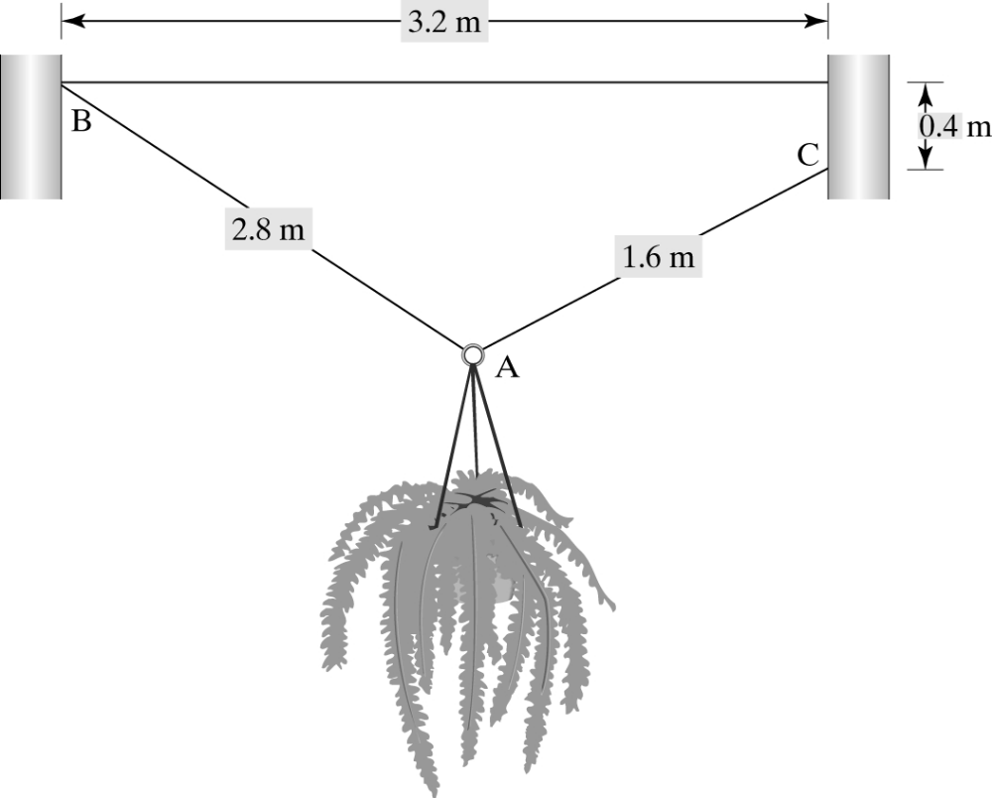

- A 8-m high granite column sustains an axial compressive load of 500 kN. If the column shortens 0.12 mm under the load, what is the diameter of the column? For granite, E = 70 GPa. Use the general analysis procedure to present your solution.

